Boultham Park Lake Restoration Project
Public consultation on the proposals for the lake interpretation
Please look at the information panels on display and answer the following questions:

Question 1
Would your experience of the lake be enhanced by having this information available? In what way?
Answer

Question 2
Has the information on the panel told you something to you which you didn’t know? Do you think this information will help you connect with, value and appreciate the nature and wildlife of the lake? In what way?
Answer

Question 3
Do you think an interpretation panel like this would have a positive influence on behaviours and why?

Answer

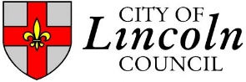
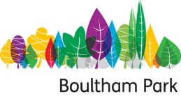

Question 4
How do you think you would use interpretation panels like this?
Answer

If there is anything else you would like to ask or tell us about this project please use the space below. Alternatively, you can email us at boultham.park@lincoln.gov.uk
Thank you for your feedback. We would like to stay in touch and keep you up to date on the lake restoration project as it progresses. If you would like to be contacted please leave your details below including what aspects of the lake restoration you would like hear about.
Name:
Address:
Contact Number / email address:
Please let us know if you might be interested in volunteering / park events / activities / skills building or any other aspect of the project

**All information will be stored in accordance with the Data Protection Act 1998. Information provided will be used only in relation to the Boultham Park Lake Restoration Project and will not be shared with other departments or organisations.

