Boultham Park Lake Restoration Project
Public consultation on the proposals for the lake interpretation
Please look at the Sculpture designs on display and answer the following questions:

Question 1
What impact do you think the sculptures will have on people coming to the park? Will the sculptures make visits more memorable? If yes, why might that be?

Answer

Question 2
Do you think the sculptures will encourage you or your family to engage more with the nature and wildlife of Boultham Park Lake? In what ways?
Answer

Question 3
How do you think you will interact with the sculptures once they have been installed?

Answer

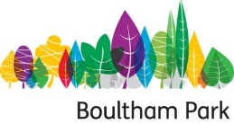
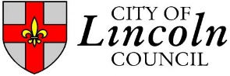

Question 4
Do you think the sculptures help shine a light on the lake’s natural and historical heritage? Would they make you want to find out more about the lake history and heritage?
If there is anything else you would like to ask or tell us about this project please use the space below. Alternatively, you can email us at boultham.park@lincoln.gov.uk
Thank you for your feedback. We would like to stay in touch and keep you up to date on the lake restoration project as it progresses. If you would like to be contacted please leave your details below including what aspects of the lake restoration you would like hear about.
Name:
Address:
Contact Number / email address:
Please let us know if you might be interested in volunteering / park events / activities / skills building or any other aspect of the project

**All information will be stored in accordance with the Data Protection Act 1998. Information provided will be used only in relation to the Boultham Park Lake Restoration Project and will not be shared with other departments or organisations

